EDUCATION STATISTICS
Education Statistics 1997 Expenditure
Education Year 1997
Enrolment 1987-1997
Technical and Vocational Training
Examination (School Candidates)
Percentage of Passes
Rodrigues Examination (School Candidates)
University of Mauritius Enrolment
University of Mauritius (output)
Mauritius Institute of Education

EDUCATION STATISTICS 1997
EXPENDITURE
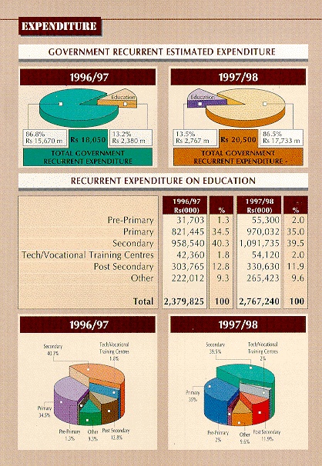

Previous
EDUCATION YEAR 97
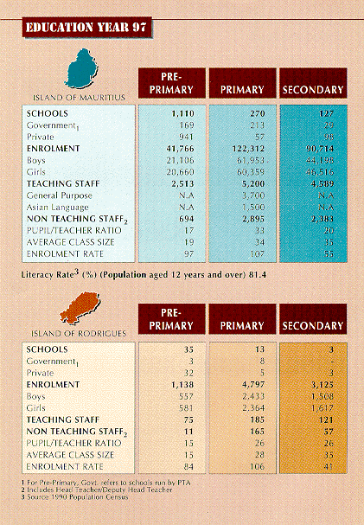
Previous
ENROLMENT 1987-1997
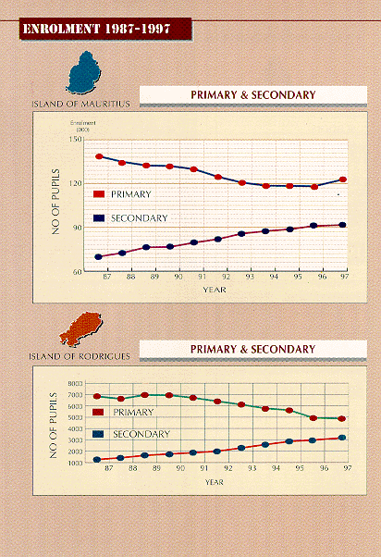
Previous
TECHNICAL AND VOCATIONAL TRAINING
Previous
EXAMINATION (SCHOOL CANDIDATES)
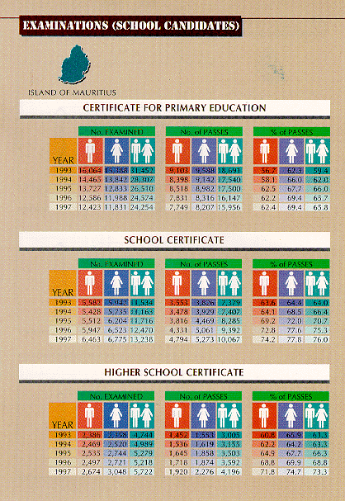
Previous
RODRIGUES
EXAMINATIONS (SCHOOL CANDIDATES)
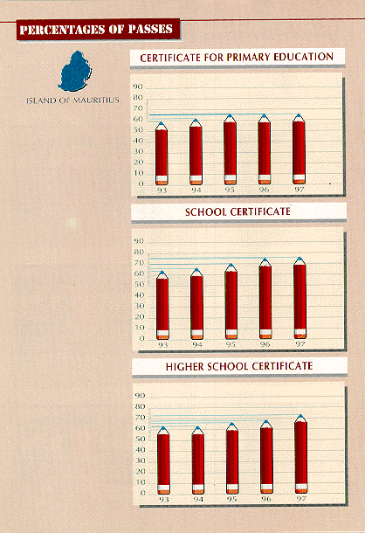
Previous
PERCENTAGE OF PASSES
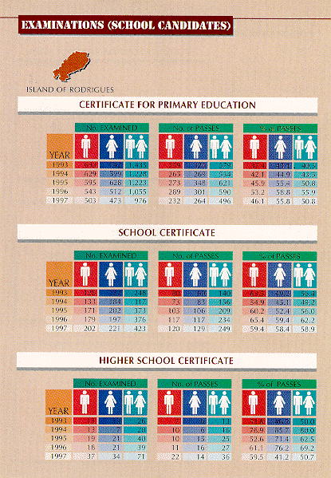
Previous
RODRIGUES EXAMINATION (SCHOOL CADIDATES)
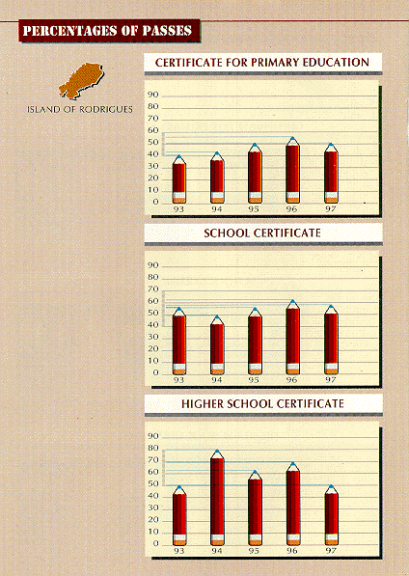
Previous
UNIVERSITY OF MAURITIUS ENROLMENT
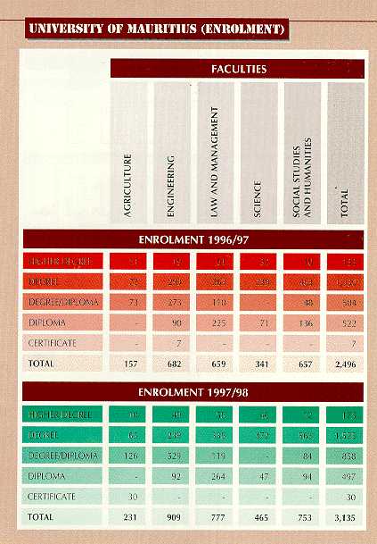
Previous
UNIVERSITY OF MAURITIUS (OUTPUT)
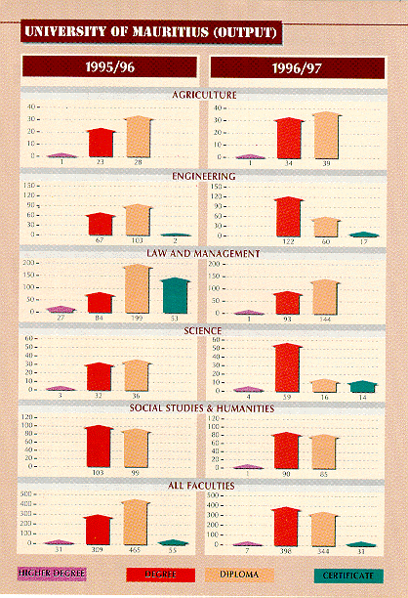
Previous
MAURITIUS INSTITUTE OF EDUCATION
