EDUCATION STATISTICS
Education Statistics 1999 Expenditure
Education Year 1999
Enrolment
Examinations (School Candidates)
Percentage of passes
Rodrigues - Examinations (School Candidates)
University of Mauritius (Enrolment)
University of Mauritius (output)
Mauritius Institute of Education
Polytechnical Institutions
Seven Educational Regions (1999)
EDUCATION STATISTICS 1999
EXPENDITURE

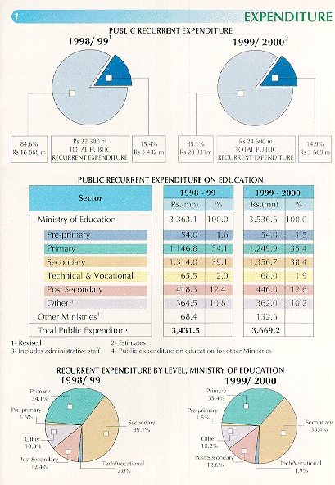
Previous
EDUCATION YEAR 99
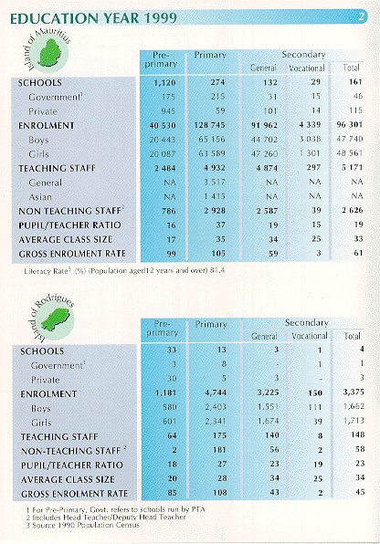
Previous
ENROLMENT
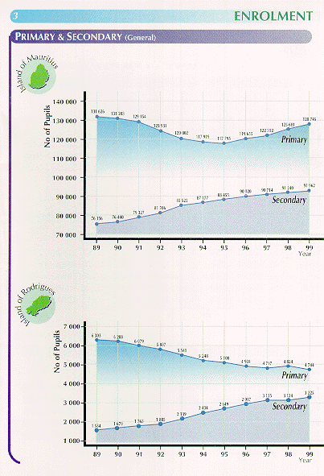
Previous
EXAMINATIONS (SCHOOL CANDIDATES)
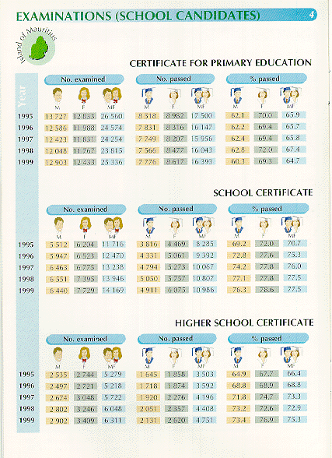
PERCENTAGE OF PASSES
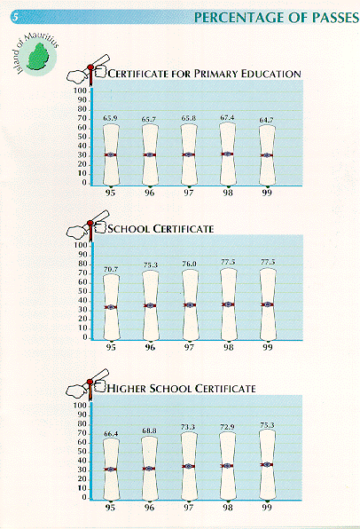
Previous
RODRIGUES
EXAMINATIONS (SCHOOL CANDIDATES)
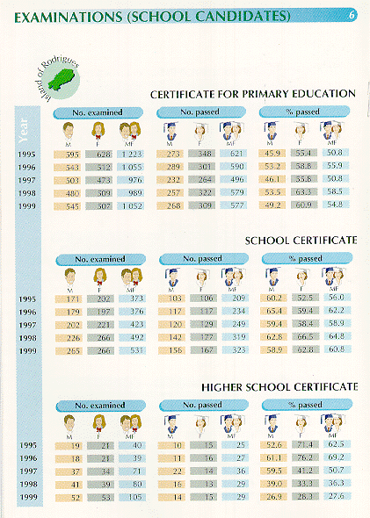
Previous
PERCENTAGE OF PASSES
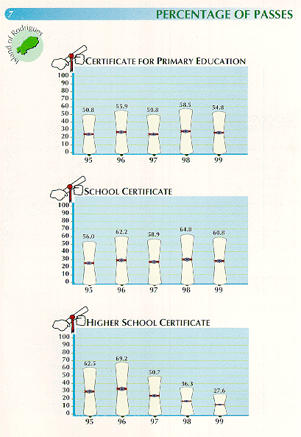
Previous
UNIVERSITY OF MAURITIUS (ENROLMENT)
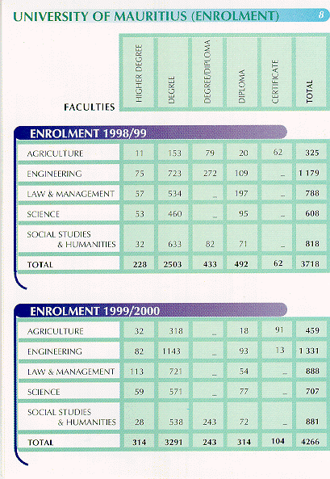
Previous
UNIVERSITY OF MAURITIUS (OUTPUT)
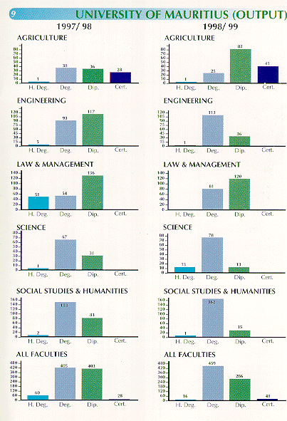
Previous
MAURITIUS INSTITUTE OF EDUCATION
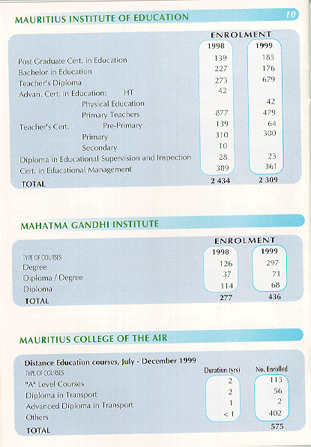
Previous
POLYTECHNICAL INSTITUTIONS
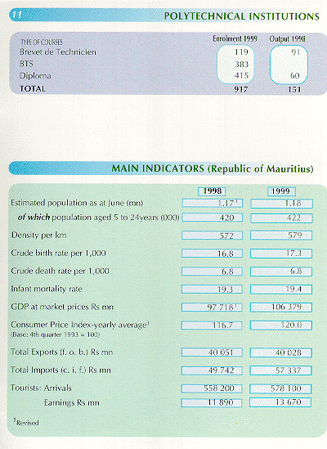
Previous
SEVEN EDUCATIONAL REGIONS (1999)
